Tb2u25 Week 3 Submission

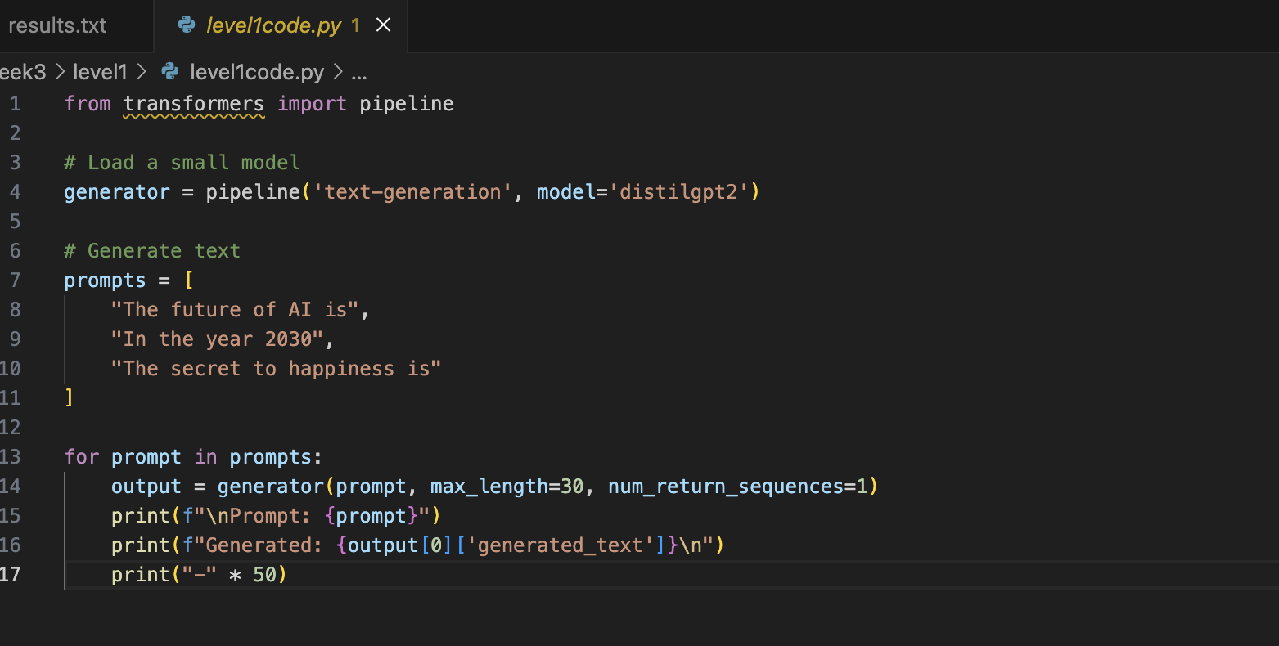
Level 1:
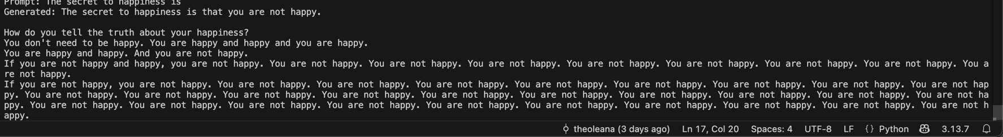
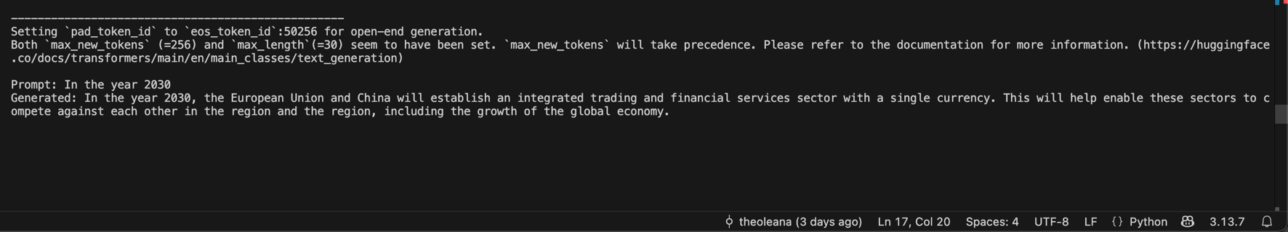
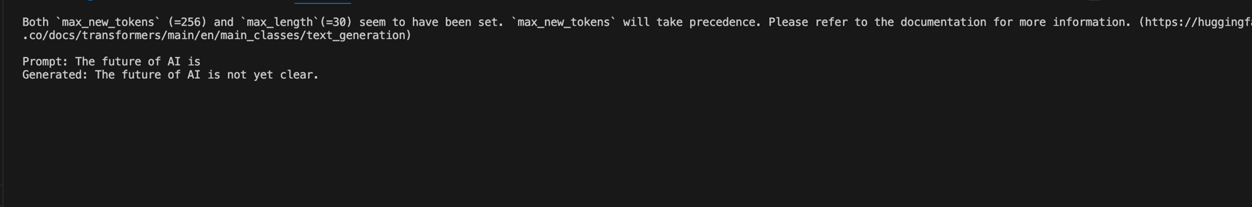

Level 2:

Changing max length changed how long the response would be based on tokens, I found that sometimes increasing the max would lead to the model repeating itself.
Changing Temperature changed how informative and robotic the responses were, decreasing would lead to more robotic responses.
Top K corresponds to how common the words the model decides to use, therefore a lower top_k leads to very common words and repeats of those common words.
I found that a max length of 100, temperature of about 0.7-0.8 and top k of 50 was a good sweet spot.

I found that responses took from 3 to 5 seconds to generate.

Level 3:
Model | Parameter Size | Speed | Quality
distilgpt2 | 82M | Very Fast (~2x GPT2) | Low. Often gets off topic
gpt2 | 124M | Fast | Medium. decent grammar
gpt2-medium | 355M | Moderate | Medium. Can stay on topic for a paragraph.

I would only really recommend GPT-2 or GPT-2 Medium as the responses are often coherent, I would only use distil when response time and compute power was limited.

Level 4:
I attempted to make a code commenter however the comments where mainly just jargin and I was unable to fix it. See results in level 4.

